Great—this is exactly how a Principal Consultant interview panel evaluates you:
👉 “Can you map every JD line → to a real capability + system design justification?”
Below is a clean, structured mapping of the JD into:
- AI vs Non-AI
- What it means
- How you justify it in system design
- What you should say in interview

🧭 1. AI vs Non-AI Responsibility Mapping (Core Table)

🧠 A. AI-Specific Responsibilities
JD Requirement | What It REALLY Means | System Design Justification | What You Say in Interview
AI-first delivery workflows | Replace manual SDLC with AI-assisted dev | Copilot in coding, testing, CI/CD pipelines | “We reduced dev effort by 30–40% using AI-assisted SDLC”
Intelligent orchestration | AI-driven workflows (agents) | Multi-agent system (planner, executor, validator) | “I use agent orchestration for task automation, not just LLM calls”
AI-driven applications | AI embedded in workflows | RAG + APIs + LLM integration | “AI is inside business flow, not a chatbot layer”
GitHub Copilot across SDLC | Mandatory AI coding culture | Copilot for code gen, tests, infra templates | “We enforce Copilot adoption with prompt libraries”
Copilot-assisted modernization | AI for legacy transformation | Code summarization + refactoring pipelines | “We migrate legacy systems 2x faster using AI-assisted analysis”
Responsible AI | Governance + security | PII masking, audit logs, RBAC | “Every AI response is filtered and compliant”
Azure OpenAI + AI Services | Enterprise LLM platform usage | LLM API layer in architecture | “All AI capabilities exposed via controlled API layer”
RAG architectures | Grounded AI systems | Vector DB + retrieval + context builder | “We never send raw data; only Top-K context is injected”
Context & grounding strategies | Context window optimization | Token budgeting + re-ranking | “We control hallucination using strict context pipelines”
Agentic AI systems | Multi-agent orchestration | Planner + Executor + Validator agents | “Agents coordinate workflows, not just generate text”
Memory systems (implicit in JD) | Persistent intelligence | Short-term + long-term memory layers | “Memory is externalized, not inside prompt”
Cost/performance optimization | AI efficiency | Token limits + caching + async calls | “We optimize tokens per request to control cost”

⚙️ B. Non-AI (Core Engineering + Consulting)
JD Requirement | What It REALLY Means | System Design Justification | What You Say in Interview
Own architecture | End-to-end system ownership | Microservices + API gateway + event-driven | “I define architecture blueprint and enforce consistency”
Scalable & robust systems | Enterprise-grade design | Load balancing, resiliency, DR | “System handles failure gracefully across regions”
Engineering excellence | Code quality + standards | Clean architecture + DDD | “We enforce coding standards and reusable components”
Multi-project execution | Program-level oversight | Shared platforms + reusable services | “I ensure consistency across multiple teams”
Client collaboration | Business + tech bridge | Requirement → architecture mapping | “I translate business problems into technical solutions”
At-risk project recovery | Crisis handling | Root cause: architecture / delivery | “I diagnose whether issue is tech, process, or scope”
Agile / DevOps / CI-CD | Delivery maturity | Pipelines + automation | “Everything is automated from build to deployment”
Cloud-native architecture (Azure) | Modern infra design | App Services, AKS, Functions | “We choose compute based on workload pattern”
Security & compliance | Enterprise readiness | Identity, RBAC, Key Vault | “Security is embedded, not added later”
Observability | Production readiness | Logs, metrics, tracing | “We design for monitoring from day 1”
Pre-sales & solutioning | Business impact | Estimation + PoC + proposals | “I connect architecture decisions to ROI”
Team leadership | Mentoring engineers | Code reviews + architecture reviews | “I elevate team capability, not just deliver projects”
Innovation leadership | Thought leadership | Accelerators + frameworks | “We build reusable assets to scale delivery”

🧠 2. Combined View (How AI + Non-AI Work Together)
This is where most candidates fail.

👉 Real Expectation:
Layer | AI Role | Non-AI Role
UI | Copilot UX | Web / mobile engineering
API | LLM orchestration | API design
Business Logic | Agents | Microservices
Data | RAG + memory | DB design
Infra | AI services | Cloud architecture
Dev | Copilot coding | Engineering discipline

🎯 3. Example Mapping (End-to-End Justification)

JD Line:
“Design RAG architectures with grounding”

Your Answer:
- AI:
  - Vector search using Azure AI Search
  - Top-K retrieval
  - Context ranking
- Non-AI:
  - Data ingestion pipelines
  - API orchestration
  - caching
👉 Final statement:
“We separate retrieval from generation, enforce token budgets, and inject only relevant context to ensure accuracy and cost efficiency.”

⚠️ 4. What Interviewers REALLY Check
They are not checking if you know buzzwords.
They check:

❌ Weak Candidate
- “We use Azure OpenAI”
- “We use RAG”

✅ Strong Candidate
- Explains:
  - how many tokens
  - how context is filtered
  - how memory is stored
  - trade-offs

🧩 5. Final Mental Model (Use This in Interview)
AI Layer:
- LLM
- RAG
- Agents
- Memory

Non-AI Layer:
- APIs
- Microservices
- Cloud infra
- DevOps

Glue:
- Orchestration
- Token optimization
- Governance

🚀 6. Your Positioning (Very Important)
Given your background:
👉 You should present yourself as:
“AI-enabled Architect with strong delivery + system design backbone”
NOT:
- pure AI engineer
- NOT pure delivery manager

💡 If you want next step
I can:
- Run a mock interview (panel style) where they challenge each line
- Or create a 1-page answer script you can memorize
- Or map this to real Azure + .NET implementation (code-level)

Short answer: we touched them—but not at the depth expected for this role.
These two lines are actually the hardest + most differentiating parts of the JD
Let’s map them properly so you can defend them in an interview.

🧠 1. Deep Expertise in LLM Integration (FULL Breakdown)

🔹 What the JD REALLY expects
Not:
- “I can call an LLM API”
But:
- You can engineer the entire LLM interaction layer

🧩 A. Prompt Engineering (Production-Level)

You must handle:
Level | What it means
Basic | role + instruction
Advanced | structured prompts, few-shot
Expert | dynamic prompt pipelines

✅ Production Pattern
System Prompt (strict rules)
+ Task Template
+ Retrieved Context (RAG)
+ Memory Summary
+ User Query
👉 Key expectation:
- Prompts are modular + reusable + versioned

🧠 B. Context & Grounding Strategies
This is where context window optimization meets RAG
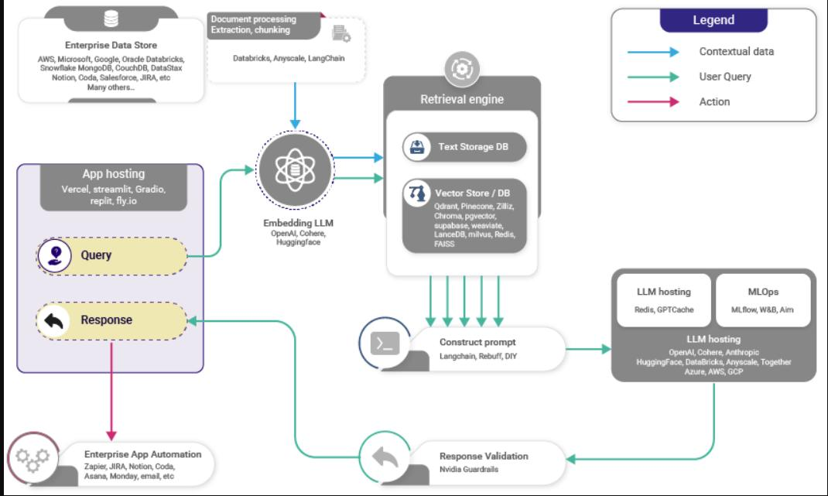
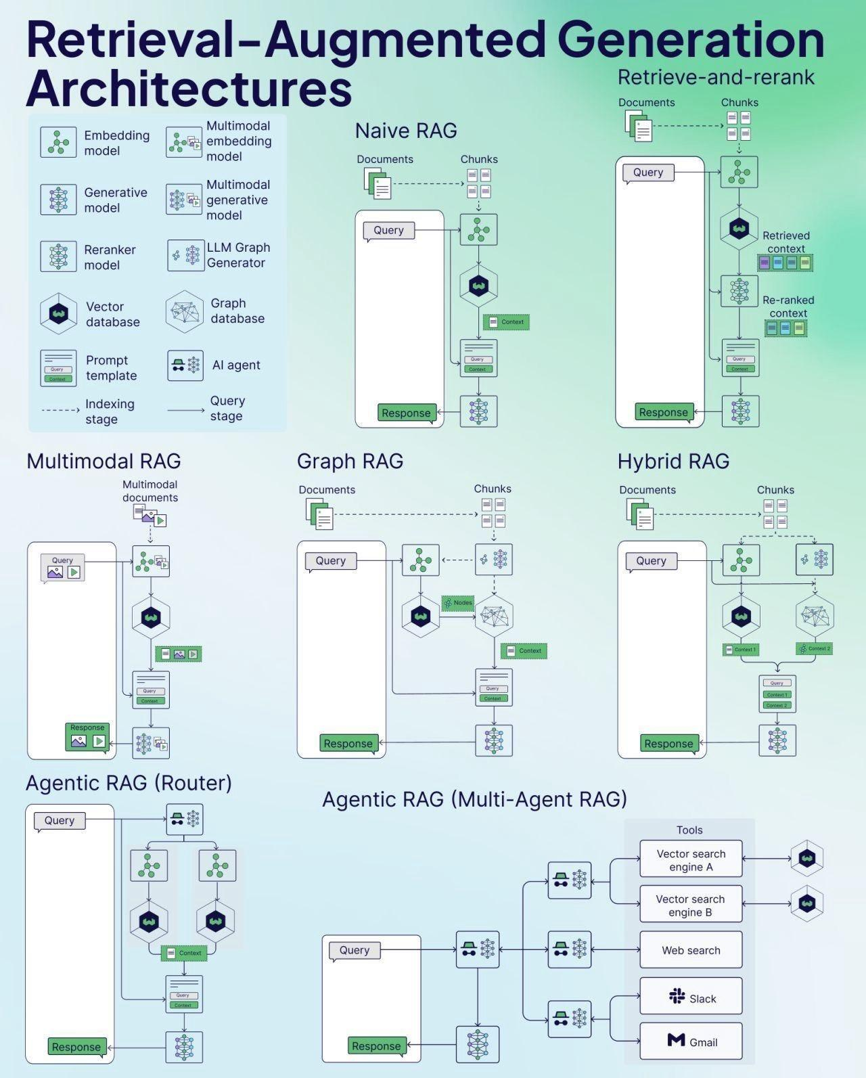
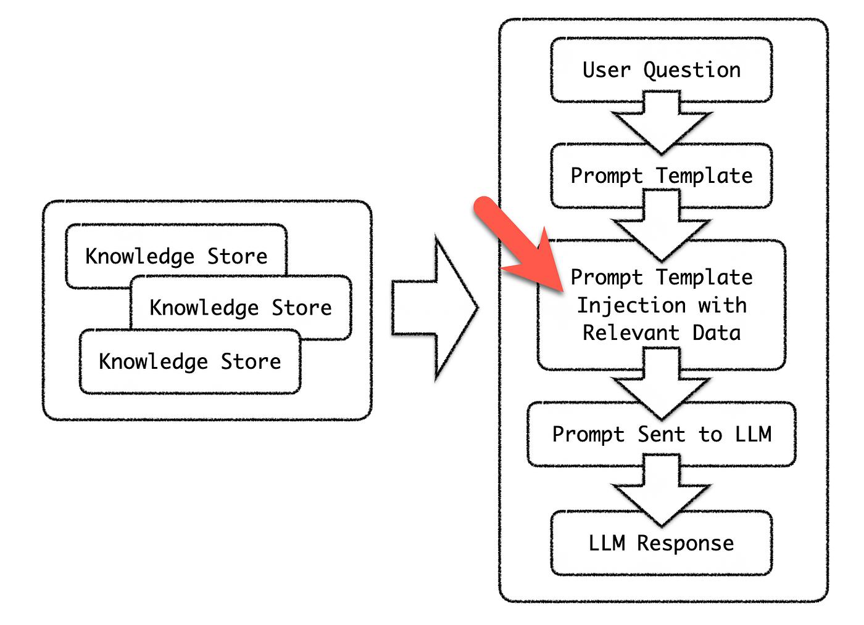
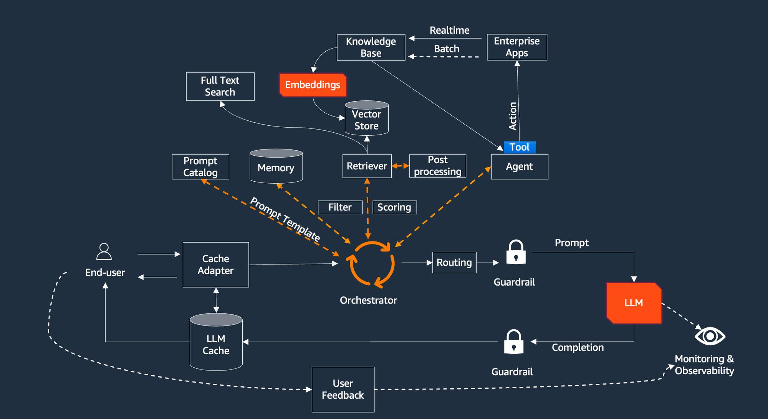
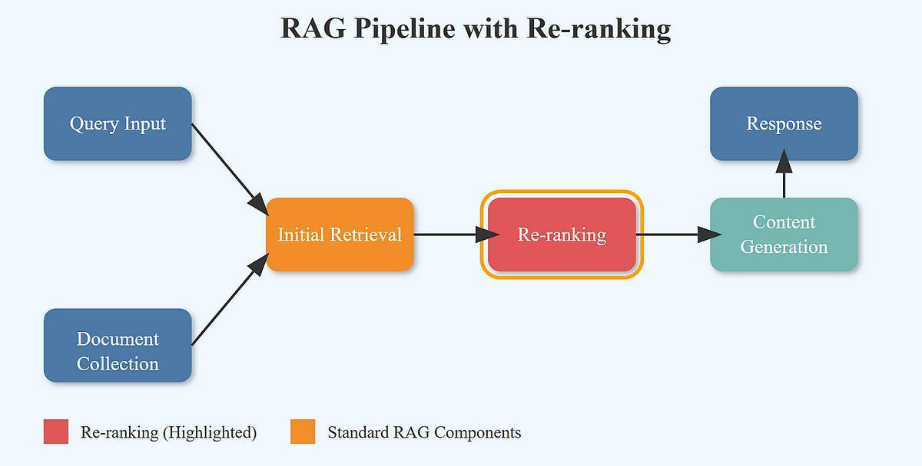
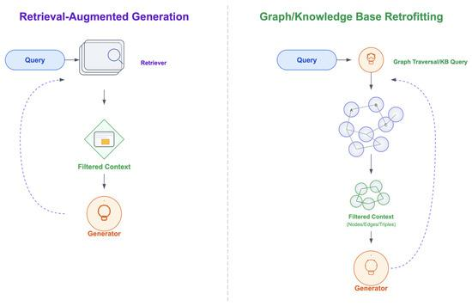
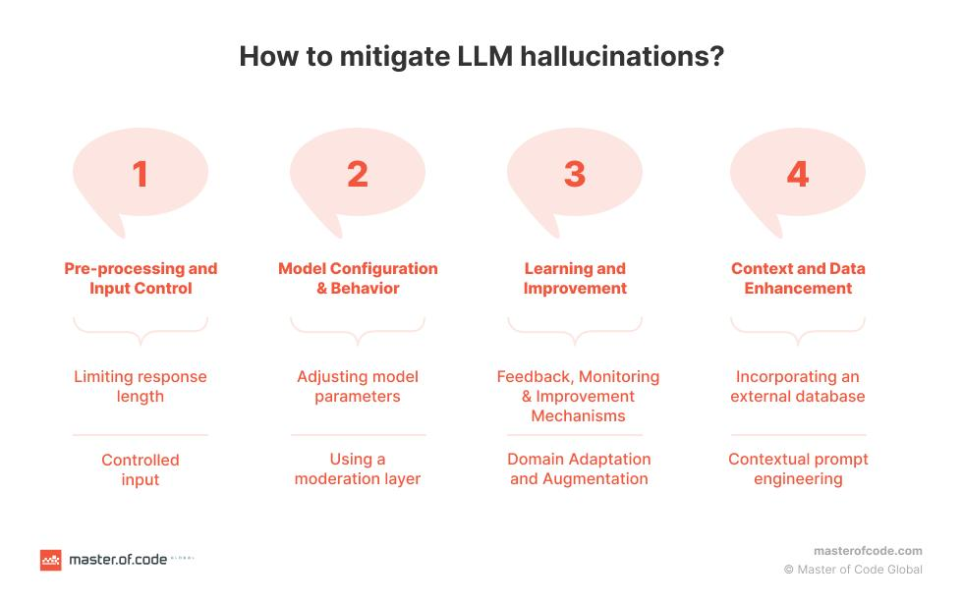

You must explain:

1. Grounding
- LLM answers ONLY from:
  - enterprise docs
  - APIs
  - memory
👉 “No grounding = hallucination”

2. Context Construction Pipeline
Retrieve → Re-rank → Filter → Compress → Inject

3. Anti-Hallucination Design
- Force citation
- Use structured outputs
- Confidence scoring

🤖 C. Copilot / Conversational Systems
You must design:
- Chat systems
- Embedded copilots (inside apps)
- Workflow assistants
👉 Difference:
- Chatbot = Q&A
- Copilot = does work + calls tools

🧠 D. Intelligent Business Workflows
Example:
“Approve loan”
Flow:
- LLM understands intent
- Calls API
- Validates rules
- Explains decision
👉 This is LLM + system integration, not just AI.

🤖 2. Agentic AI Systems (FULL Breakdown)
This is top 1% expectation

🧩 A. What “Agentic AI” Means Here
Not:
- simple chatbot
But:
- autonomous systems that plan, act, and adapt

🧠 B. Architecture You Must Explain
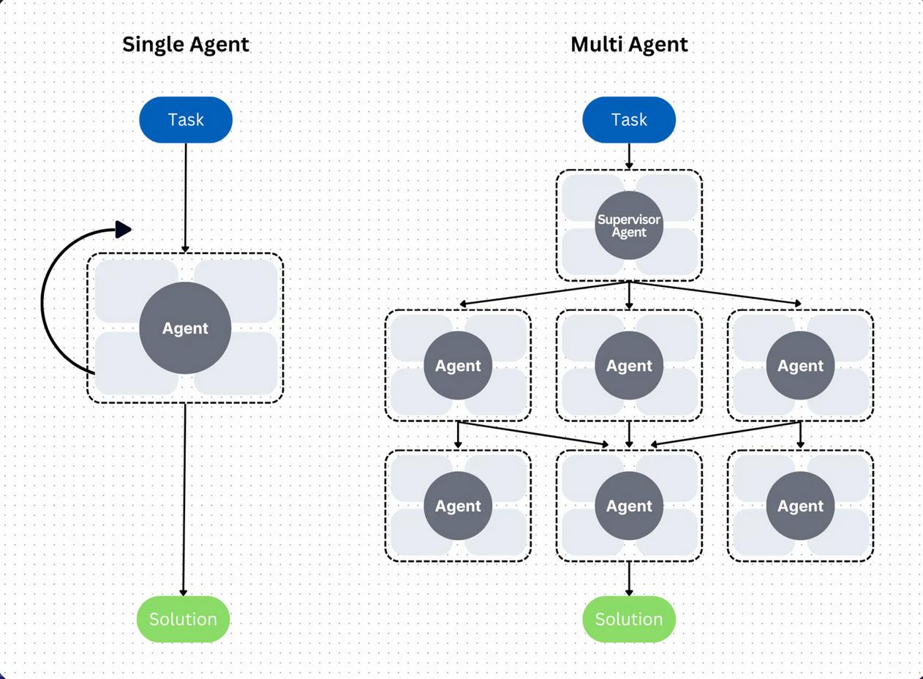
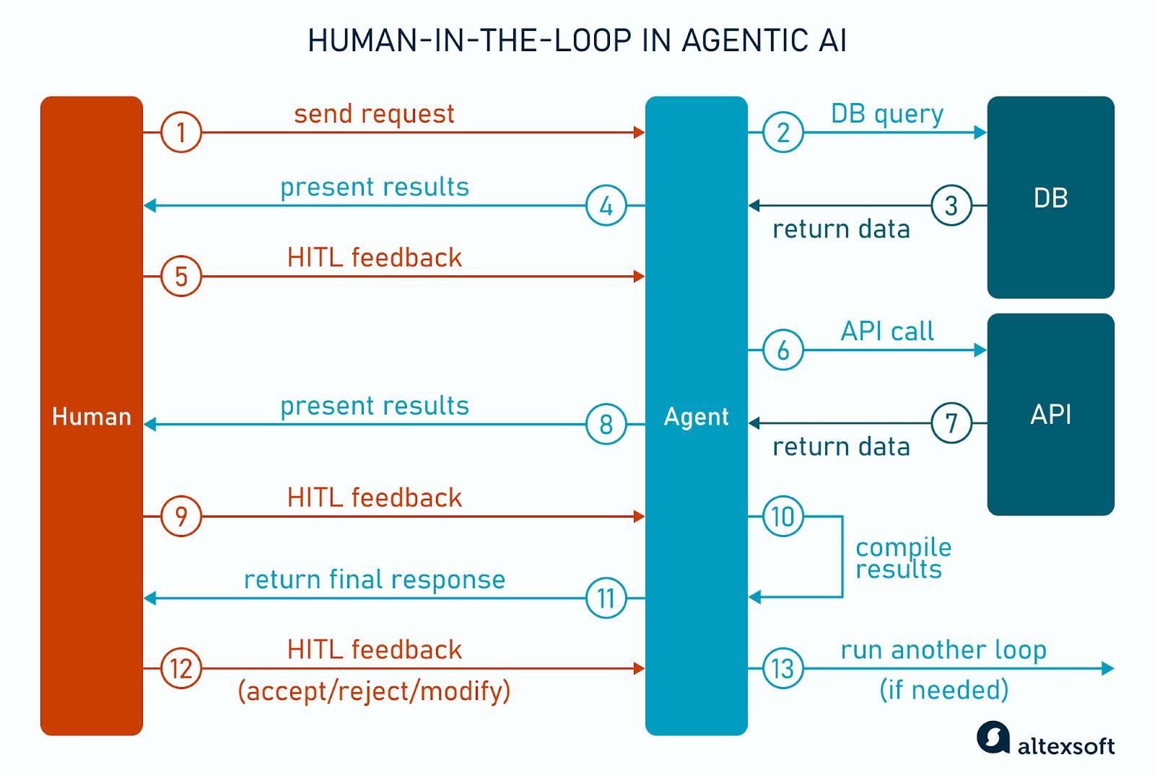
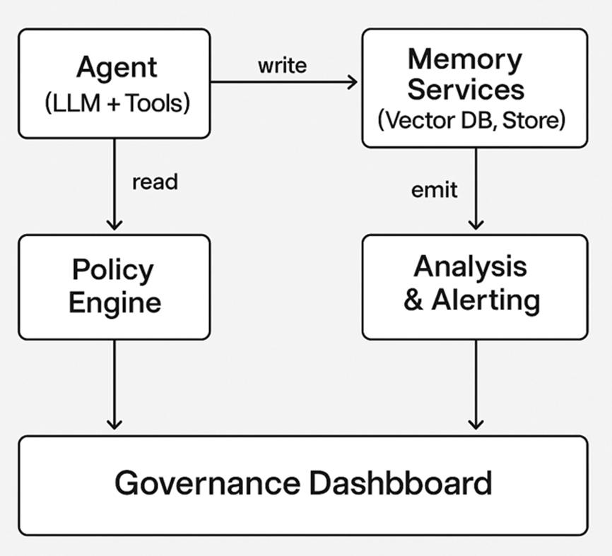
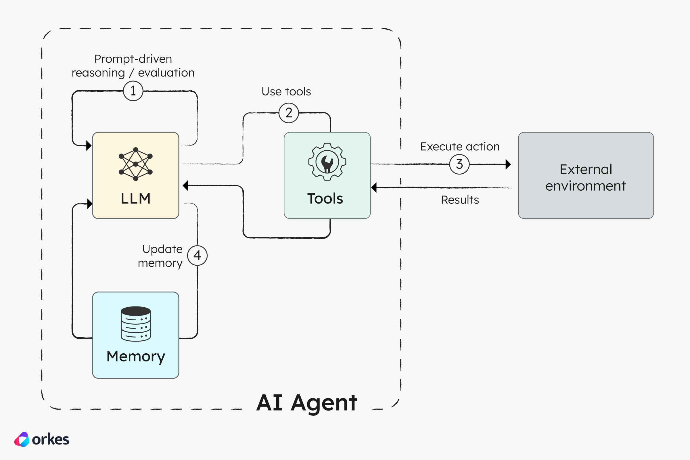
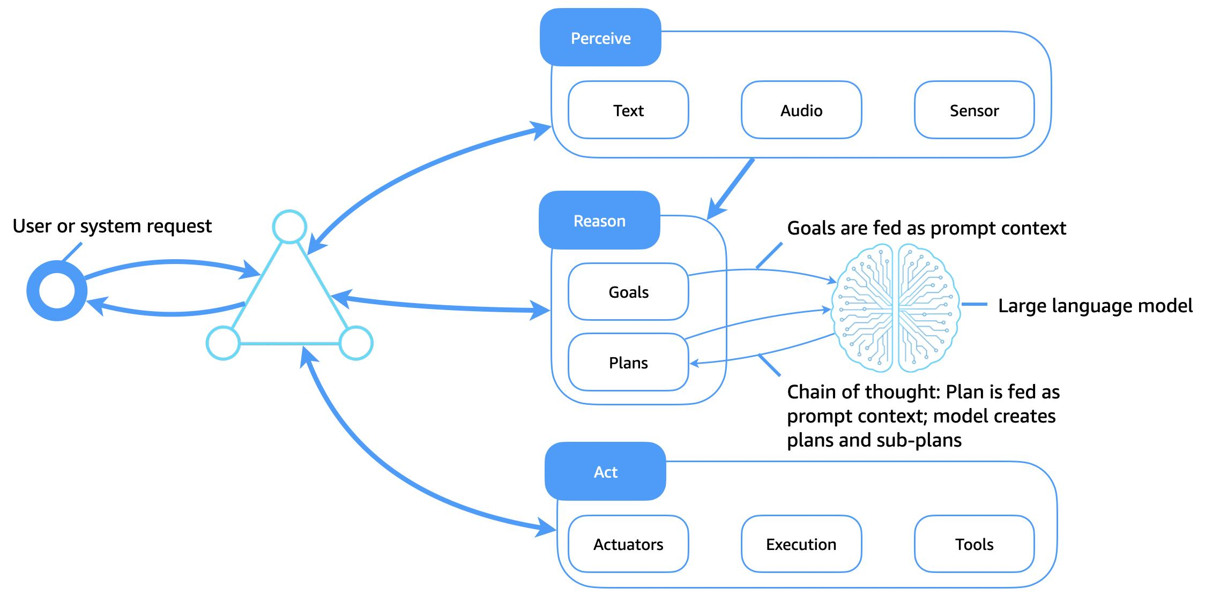
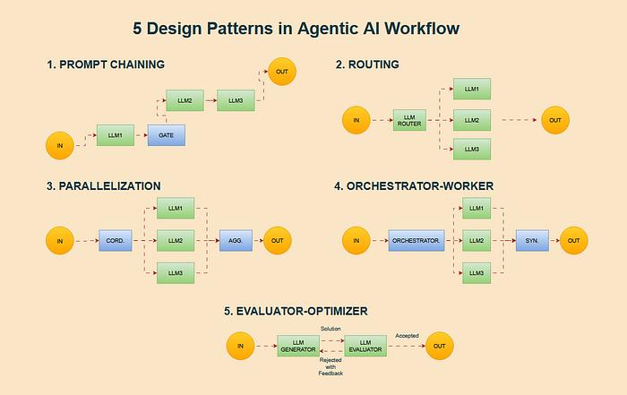

🔧 C. Core Components

1. Agents
Agent | Role
Planner | Breaks task
Executor | Calls tools/APIs
Retriever | Fetches data
Validator | Ensures correctness
Responder | Final output

2. Tools
Agents don’t just think—they act:
- APIs
- databases
- workflows
- external systems
👉 Example:
- “Check loan status” → calls banking API

3. Memory (Critical)
Type | Purpose
Short-term | current task
Long-term | user history
Shared | across agents

4. Human-in-the-Loop
Mandatory in enterprise:
- approvals
- overrides
- audits
👉 Example:
- high-risk loan → human approval

5. Orchestration
Who controls agents?
Options:
- rule-based
- LLM-based planner
- workflow engine

📊 D. Enterprise-Ready Operations
This is where most candidates fail.

🔹 Observability
You must track:
- prompts
- responses
- latency
- failures
👉 Equivalent of:
- logs + metrics for AI

🔹 Governance
- who can access what data
- audit trails
- policy enforcement

🔹 Cost Optimization
LLMs are expensive:
You must:
- cache responses
- reduce tokens
- choose smaller models where possible

🔹 Performance Optimization
- async calls
- streaming responses
- batching

⚠️ 3. What You Might Have Missed Earlier
We covered:
✔ RAG
✔ Memory
✔ Context
But we did NOT fully emphasize:
❗ Prompt lifecycle management
❗ Agent orchestration depth
❗ Enterprise observability/governance
❗ Tool integration inside agents

🎯 4. How to Answer This in Interview (Perfect Answer)
If they ask:
👉 “Explain LLM integration and agentic systems”
You say:
“I design LLM systems with a clear separation of concerns—prompt templates, retrieval pipelines, and memory layers.
For grounding, I use RAG with re-ranking and strict token budgeting to ensure accuracy and cost efficiency.
For complex workflows, I design agentic systems where a planner agent decomposes tasks, executor agents call enterprise APIs, and validator agents enforce compliance, with human-in-the-loop for critical decisions.
I also ensure enterprise readiness through observability, governance, and cost optimization.”

💡 Final Insight
👉 These two lines alone differentiate:
- Senior Architect ❌
- Principal Consultant ✅
Because they require:
- System thinking
- AI depth
- Enterprise experience

🚀 If you want next level
I can:
- Take ONE use case (bank / IoT / retail)
- And make you design agent + LLM system live (interview simulation)
That’s the fastest way to master this.

